Windows from the Home Depot… in Cabos San Lucas
This is the first in a series of articles with pictures of items we found available at the Windows Department (Dept. #30 435 5242) at the Home Depot in Cabos San Lucas, Baja California Sur (BCS), Mexico.
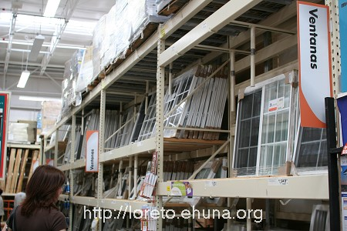
Janelle checks out the available windows (“Ventanas”)
<center><img src=”/pics/2007/03/homedepot/02-preview/IMG_3122.JPG”><br>
<i> Janelle checks out the available windows (“Ventanas”) </i></center>
We heard that one of our Loreto neighbors spent as much as $30,000 (thirty thousand dollars US) just on windows. And he wasn’t very happy with the quality of the windows purchased in Loreto itself (they leaked). It’s nice to know we have options.
See below for the windows that Janelle found interesting or click here for the index listing all items we found at the Home Depot in Cabos.

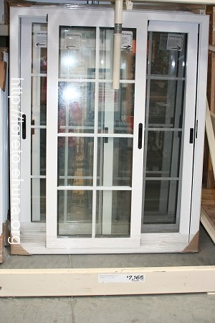
<center><img src=”/pics/2007/03/homedepot/02-preview/IMG_3123.JPG”></center>
Item No.: Windows-01
Size: 120x150
Article No.: 841192
Price: $7,165
Picture 1: <a href=”/pics/2007/03/homedepot/03-lowres/IMG_3123.JPG” target=”_blank”>Click Here</a> for low resolution (800x533)
Picture 2: <a href=”/pics/2007/03/homedepot/04-highres/IMG_3123.JPG” target=”_blank”>Click Here</a> for high resolution (3456x2304)
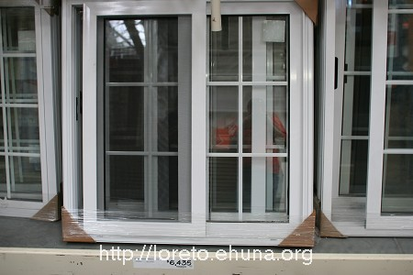
<center><img src=”/pics/2007/03/homedepot/02-preview/IMG_3123.JPG”></center>
Item No.: Windows-02
Size: 120x120
Article No.: 847839
Price: $6,435
Picture 1: <a href=”/pics/2007/03/homedepot/03-lowres/IMG_3124.JPG” target=”_blank”>Click Here</a> for low resolution (800x533)
Picture 2: <a href=”/pics/2007/03/homedepot/04-highres/IMG_3124.JPG” target=”_blank”>Click Here</a> for high resolution (3456x2304)
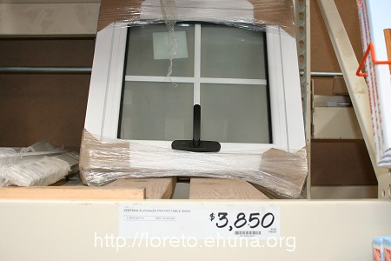
<center><img src=”/pics/2007/03/homedepot/02-preview/IMG_3125.JPG”></center>
Item No.: Windows-03
Size:60x60
Article No.: 847776
Price: $3,850
Picture 1: <a href=”/pics/2007/03/homedepot/03-lowres/IMG_3125.JPG” target=”_blank”>Click Here</a> for low resolution (800x533)
Picture 2: <a href=”/pics/2007/03/homedepot/04-highres/IMG_3125.JPG” target=”_blank”>Click Here</a> for high resolution (3456x2304)
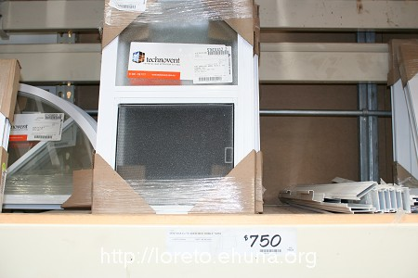
<center><img src=”/pics/2007/03/homedepot/02-preview/IMG_3126.JPG”></center>
Item No.: Windows-04
Size: 60x40
Article No.: 522503
Price: $750
Picture 1: <a href=”/pics/2007/03/homedepot/03-lowres/IMG_3126.JPG” target=”_blank”>Click Here</a> for low resolution (800x533)
Picture 2: <a href=”/pics/2007/03/homedepot/04-highres/IMG_3126.JPG” target=”_blank”>Click Here</a> for high resolution (3456x2304)
Aluminum Windows; seem to be a bit cheaper. I’m not sure of the quality. Technovent Brands, http://www.technovent.mx
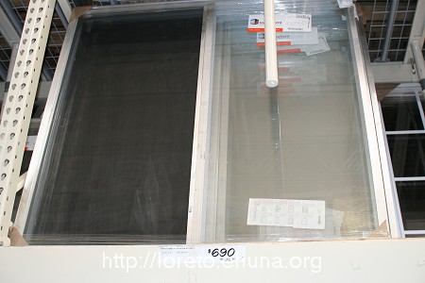
<center><img src=”/pics/2007/03/homedepot/02-preview/IMG_3127.JPG”></center>
Item No.: Windows-05
Size: 120x120
Article No.: 521861
Price: $690
Picture 1: <a href=”/pics/2007/03/homedepot/03-lowres/IMG_3127.JPG” target=”_blank”>Click Here</a> for low resolution (800x533)
Picture 2: <a href=”/pics/2007/03/homedepot/04-highres/IMG_3127.JPG” target=”_blank”>Click Here</a> for high resolution (3456x2304)
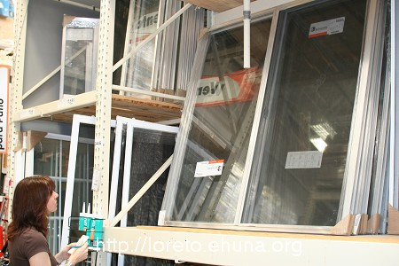
<center><img src=”/pics/2007/03/homedepot/02-preview/IMG_3128.JPG”></center>

No specific item here; just Janelle looking cute.
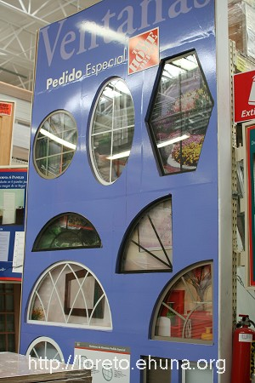
<center><img src=”/pics/2007/03/homedepot/02-preview/IMG_3129.JPG”></center>
Custom Windows can also be requested. We couldn’t get any prices on any of those displayed though.

