Kitchens from the Home Depot… in Cabos San Lucas
This is the third in a series of articles with pictures of items we found available at the Kitchen Department at the Home Depot in Cabos San Lucas, BCS, Mexico.
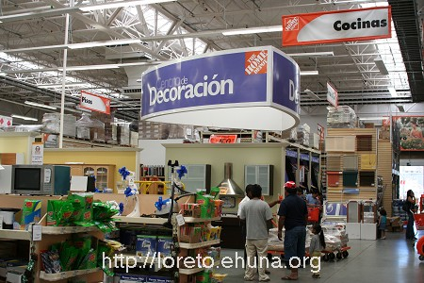
The Kitchen Department (“Cocinas”)
is right behind the Decorations Department
<center><img src=”/pics/2007/03/homedepot/02-preview/IMG_3120.JPG”><br><i> The Kitchen Department (“Cocinas”)<br> is right behind the Decorations Department </i></center>
See below for some of the available kitchens or <a href=”/archives/cat_10_home_depot.html”>click here</a> for the index listing all items we found at the Home Depot in Cabos.

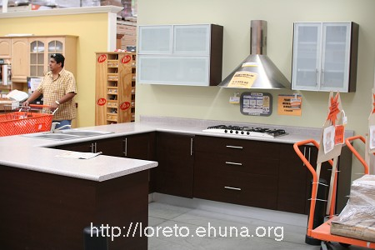
<center><img src="/pics/2007/03/homedepot/02-preview/IMG_3161.JPG"></center>
Item No.: Kitchen-01
Article No.: Huesca (Special Order)
Price: $86,404
Picture 1: <a href="/pics/2007/03/homedepot/03-lowres/IMG_3161.JPG" target="_blank">Click Here</a> for low resolution (800x533)
Picture 2: <a href="/pics/2007/03/homedepot/04-highres/IMG_3161.JPG" target="_blank">Click Here</a> for high resolution (3456x2304)
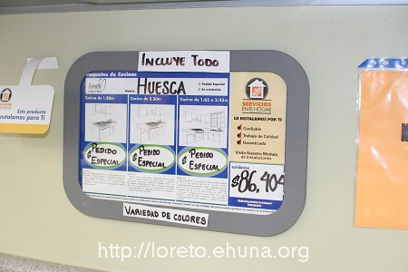
<center><img src="/pics/2007/03/homedepot/02-preview/IMG_3160.JPG"></center>
Item No.: Kitchen-02 (Price of Kitchen-01)
Picture 1: <a href="/pics/2007/03/homedepot/03-lowres/IMG_3160.JPG" target="_blank">Click Here</a> for low resolution (800x533)
Picture 2: <a href="/pics/2007/03/homedepot/04-highres/IMG_3160.JPG" target="_blank">Click Here</a> for high resolution (3456x2304)
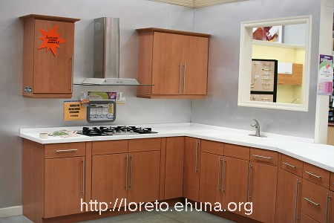
<center><img src="/pics/2007/03/homedepot/02-preview/IMG_3163.JPG"></center>
Item No.: Kitchen-03
Article No.: Canton
Price: $21,531
Picture 1: <a href="/pics/2007/03/homedepot/03-lowres/IMG_3163.JPG" target="_blank">Click Here</a> for low resolution (800x533)
Picture 2: <a href="/pics/2007/03/homedepot/04-highres/IMG_3163.JPG" target="_blank">Click Here</a> for high resolution (3456x2304)
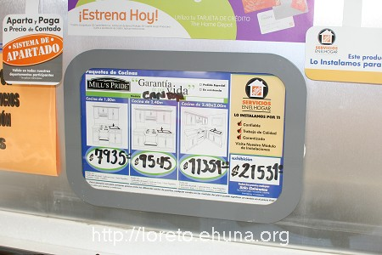
<center><img src="/pics/2007/03/homedepot/02-preview/IMG_3162.JPG"></center>
Item No.: Kitchen-04 (Price of Kitchen-03)
Picture 1: <a href="/pics/2007/03/homedepot/03-lowres/IMG_3162.JPG" target="_blank">Click Here</a> for low resolution (800x533)
Picture 2: <a href="/pics/2007/03/homedepot/04-highres/IMG_3162.JPG" target="_blank">Click Here</a> for high resolution (3456x2304)
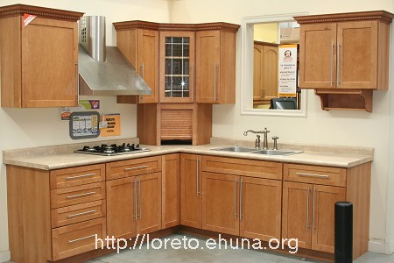
<center><img src="/pics/2007/03/homedepot/02-preview/IMG_3165.JPG"></center>
Item No.: Kitchen-05
Article No.: Thorton Tofee
Price: $63,811
Picture 1: <a href="/pics/2007/03/homedepot/03-lowres/IMG_3165.JPG" target="_blank">Click Here</a> for low resolution (800x533)
Picture 2: <a href="/pics/2007/03/homedepot/04-highres/IMG_3165.JPG" target="_blank">Click Here</a> for high resolution (3456x2304)
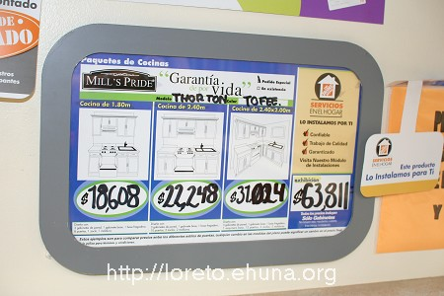
<center><img src="/pics/2007/03/homedepot/02-preview/IMG_3164.JPG"></center>
Item No.: Kitchen-06 (Price of Kitchen-05)
Picture 1: <a href="/pics/2007/03/homedepot/03-lowres/IMG_3164.JPG" target="_blank">Click Here</a> for low resolution (800x533)
Picture 2: <a href="/pics/2007/03/homedepot/04-highres/IMG_3164.JPG" target="_blank">Click Here</a> for high resolution (3456x2304)
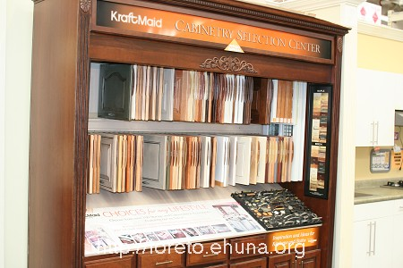
<center><img src="/pics/2007/03/homedepot/02-preview/IMG_3158.JPG"></center>
Item No.: Kitchen-07
KraftMaid – Cabinet Selection Center
Picture 1: <a href="/pics/2007/03/homedepot/03-lowres/IMG_3158.JPG" target="_blank">Click Here</a> for low resolution (800x533)
Picture 2: <a href="/pics/2007/03/homedepot/04-highres/IMG_3158.JPG" target="_blank">Click Here</a> for high resolution (3456x2304)

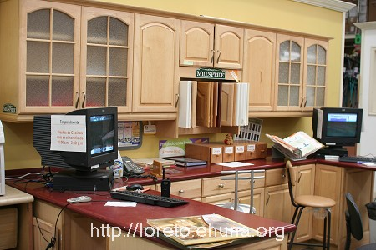
<center><img src="/pics/2007/03/homedepot/02-preview/IMG_3159.JPG"></center>
Item No.: Kitchen-08
Article No.: Mill’s Pride (Special Order)
Price: $52,911
Picture 1: <a href="/pics/2007/03/homedepot/03-lowres/IMG_3159.JPG" target="_blank">Click Here</a> for low resolution (800x533)
Picture 2: <a href="/pics/2007/03/homedepot/04-highres/IMG_3159.JPG" target="_blank">Click Here</a> for high resolution (3456x2304)

