Cabos Home Depot - Bathroom
This is the fifth in a series of articles with pictures of items we found available at the Bathroom Department at the Home Depot in Cabos San Lucas, BCS, Mexico.
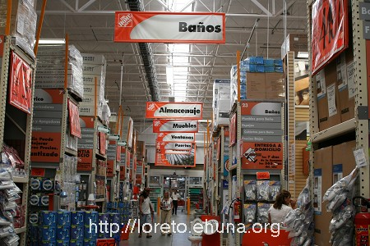
The Bathroom Department (“Banos”) at the
Home Depot in Cabos, Baja California Sur (BCS), Mexico
<center><img src=”/pics/2007/03/homedepot/02-preview/IMG_3119.JPG”><br><i> The Bathroom Department (“Banos”) at the<br> Home Depot in Cabos, Baja California Sur (BCS), Mexico </i></center>
See below for sinks, toilets, faucets and more or <a href=”/archives/cat_10_home_depot.html”>click here</a> for the index listing all items we found at the Home Depot in Cabos.
<b>Disclaimer</b>: please note that these items were available on 3/4/2007. Call Home Depot in Cabos before driving down to make sure the item you're interested in is still available and the price has not changed. If you'd like to zoom in on a price or a detail, download the "high-resolution" image (3456x2304).

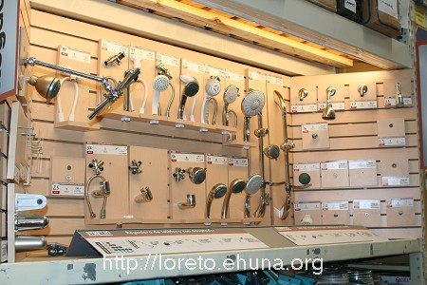
<center><a href="/pics/2007/03/homedepot/03-lowres/IMG_3153.JPG" target="_blank"><img src="/pics/2007/03/homedepot/02-preview/IMG_3153.JPG"></a></center>
Item No.: Bathroom-01
Shower Heads - Download high-resolution picture to view prices and article numbers
Picture 1: <a href="/pics/2007/03/homedepot/03-lowres/IMG_3153.JPG" target="_blank">Click Here</a> for low resolution (800x533)
Picture 2: <a href="/pics/2007/03/homedepot/04-highres/IMG_3153.JPG" target="_blank">Click Here</a> for high resolution (3456x2304)
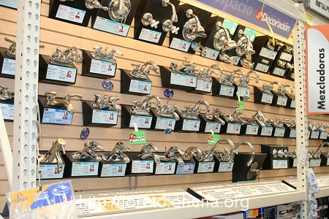
<center><a href="/pics/2007/03/homedepot/03-lowres/IMG_3154.JPG" target="_blank"><img src="/pics/2007/03/homedepot/02-preview/IMG_3154.JPG"></a></center>
Item No.: Bathroom-02
Faucets - Download high-resolution picture to view prices and article numbers
Picture 1: <a href="/pics/2007/03/homedepot/03-lowres/IMG_3154.JPG" target="_blank">Click Here</a> for low resolution (800x533)
Picture 2: <a href="/pics/2007/03/homedepot/04-highres/IMG_3154.JPG" target="_blank">Click Here</a> for high resolution (3456x2304)
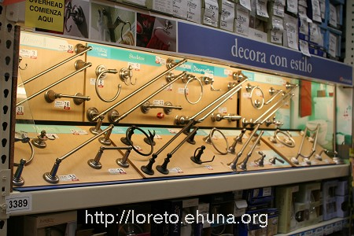
<center><a href="/pics/2007/03/homedepot/03-lowres/IMG_3152.JPG" target="_blank"><img src="/pics/2007/03/homedepot/02-preview/IMG_3152.JPG"></a></center>
Item No.: Bathroom-03
Towel Racks - Download high-resolution picture to view prices and article numbers
Picture 1: <a href="/pics/2007/03/homedepot/03-lowres/IMG_3152.JPG" target="_blank">Click Here</a> for low resolution (800x533)
Picture 2: <a href="/pics/2007/03/homedepot/04-highres/IMG_3152.JPG" target="_blank">Click Here</a> for high resolution (3456x2304)
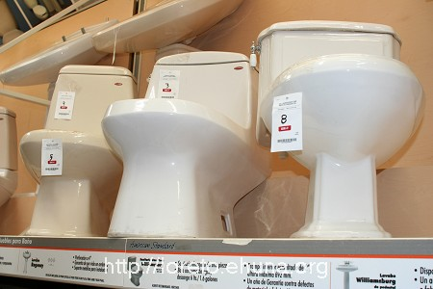
<center><a href="/pics/2007/03/homedepot/03-lowres/IMG_3145.JPG" target="_blank"><img src="/pics/2007/03/homedepot/02-preview/IMG_3145.JPG"></a></center>
Item No.: Bathroom-04
Article No.: #8 (in picture), 609071, American Standard
Price: $4,159
Article No.: #3 (in picture), 240821, American Standard
Price: $7,164
Picture 1: <a href="/pics/2007/03/homedepot/03-lowres/IMG_3145.JPG" target="_blank">Click Here</a> for low resolution (800x533)
Picture 2: <a href="/pics/2007/03/homedepot/04-highres/IMG_3145.JPG" target="_blank">Click Here</a> for high resolution (3456x2304)
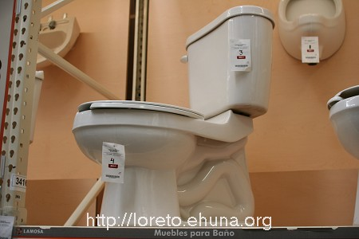
<center><a href="/pics/2007/03/homedepot/03-lowres/IMG_3146.JPG" target="_blank"><img src="/pics/2007/03/homedepot/02-preview/IMG_3146.JPG"></a></center>
Item No.: Bathroom-05
Article No.: #3 (in picture), 224919, Lomosa Brand
Price: $1,239
Article No.: #4 (in picture), 224900, Lomosa Brand
Price: $1,619
Picture 1: <a href="/pics/2007/03/homedepot/03-lowres/IMG_3146.JPG" target="_blank">Click Here</a> for low resolution (800x533)
Picture 2: <a href="/pics/2007/03/homedepot/04-highres/IMG_3146.JPG" target="_blank">Click Here</a> for high resolution (3456x2304)
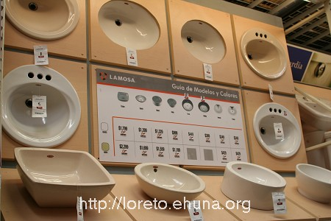
<center><a href="/pics/2007/03/homedepot/03-lowres/IMG_3147.JPG" target="_blank"><img src="/pics/2007/03/homedepot/02-preview/IMG_3147.JPG"></a></center>
Item No.: Bathroom-06
Miscellaneous Sinks
Picture 1: <a href="/pics/2007/03/homedepot/03-lowres/IMG_3147.JPG" target="_blank">Click Here</a> for low resolution (800x533)
Picture 2: <a href="/pics/2007/03/homedepot/04-highres/IMG_3147.JPG" target="_blank">Click Here</a> for high resolution (3456x2304)
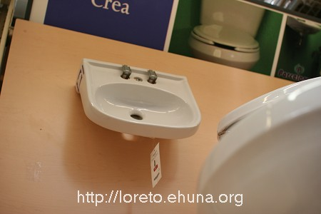
<center><a href="/pics/2007/03/homedepot/03-lowres/IMG_3148.JPG" target="_blank"><img src="/pics/2007/03/homedepot/02-preview/IMG_3148.JPG"></a></center>
Item No.: Bathroom-07
Article No.: #1 (in picture), Single Sink, 548163
Price: $159
Picture 1: <a href="/pics/2007/03/homedepot/03-lowres/IMG_3148.JPG" target="_blank">Click Here</a> for low resolution (800x533)
Picture 2: <a href="/pics/2007/03/homedepot/04-highres/IMG_3148.JPG" target="_blank">Click Here</a> for high resolution (3456x2304)
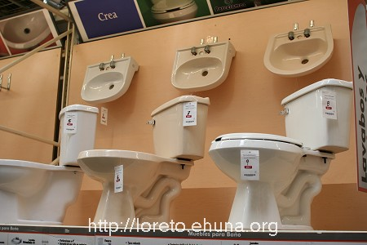
<center><a href="/pics/2007/03/homedepot/03-lowres/IMG_3149.JPG" target="_blank"><img src="/pics/2007/03/homedepot/02-preview/IMG_3149.JPG"></a></center>
Item No.: Bathroom-08
Additonal Sinks and Toilets. Prices not available.
Picture 1: <a href="/pics/2007/03/homedepot/03-lowres/IMG_3149.JPG" target="_blank">Click Here</a> for low resolution (800x533)
Picture 2: <a href="/pics/2007/03/homedepot/04-highres/IMG_3149.JPG" target="_blank">Click Here</a> for high resolution (3456x2304)
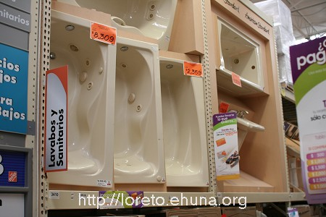
<center><a href="/pics/2007/03/homedepot/03-lowres/IMG_3150.JPG" target="_blank"><img src="/pics/2007/03/homedepot/02-preview/IMG_3150.JPG"></a></center>
Item No.: Bathroom-09
Tubs. Download high-resolution picture to zoom in for prices and details.
Picture 1: <a href="/pics/2007/03/homedepot/03-lowres/IMG_3150.JPG" target="_blank">Click Here</a> for low resolution (800x533)
Picture 2: <a href="/pics/2007/03/homedepot/04-highres/IMG_3150.JPG" target="_blank">Click Here</a> for high resolution (3456x2304)
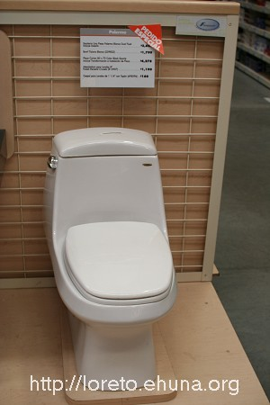
<center><a href="/pics/2007/03/homedepot/03-lowres/IMG_3151.JPG" target="_blank"><img src="/pics/2007/03/homedepot/02-preview/IMG_3151.JPG"></a></center>
Item No.: Bathroom-10
Custom Order. Download high-resolution picture to zoom in for prices and details.
Picture 1: <a href="/pics/2007/03/homedepot/03-lowres/IMG_3151.JPG" target="_blank">Click Here</a> for low resolution (800x533)
Picture 2: <a href="/pics/2007/03/homedepot/04-highres/IMG_3151.JPG" target="_blank">Click Here</a> for high resolution (3456x2304)
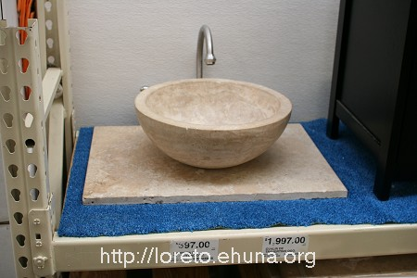
<center><a href="/pics/2007/03/homedepot/03-lowres/IMG_3166.JPG" target="_blank"><img src="/pics/2007/03/homedepot/02-preview/IMG_3166.JPG"></a></center>
Item No.: Bathroom-11
Sink. Download high-resolution picture to zoom in for prices and details.
Picture 1: <a href="/pics/2007/03/homedepot/03-lowres/IMG_3166.JPG" target="_blank">Click Here</a> for low resolution (800x533)
Picture 2: <a href="/pics/2007/03/homedepot/04-highres/IMG_3166.JPG" target="_blank">Click Here</a> for high resolution (3456x2304)

