Cabos Home Depot - Tiles
This is the sixth in a series of articles with pictures of items we found available at the Tiles Department at the Home Depot in Cabos San Lucas, BCS, Mexico.
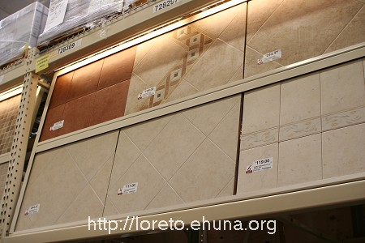
The Tiles Department at the Home Depot
in Cabos, Baja California Sur (BCS), Mexico
<center><img src=”/pics/2007/03/homedepot/02-preview/IMG_3168.JPG”><br><i> The Tiles Department at the Home Depot<br>in Cabos, Baja California Sur (BCS), Mexico </i></center>
See below for 18 types of tile or <a href=”/archives/cat_10_home_depot.html”>click here</a> for the index listing all items we found at the Home Depot in Cabos.
<b>Disclaimer</b>: please note that these items were available on 3/4/2007. Call Home Depot in Cabos before driving down to make sure the item you're interested in is still available and the price has not changed. If you'd like to zoom in on a price or a detail, download the "high-resolution" image (3456x2304).

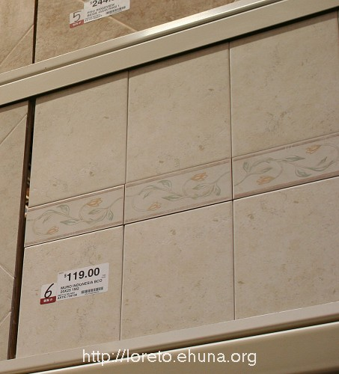
<center><a href="/pics/2007/03/homedepot/03-lowres/tiles/IMG_3168/IMG_3168_6.JPG" target="_blank"><img src="/pics/2007/03/homedepot/02-preview/tiles/IMG_3168/IMG_3168_6.JPG"></a></center>
Item No.: Tiles-01
Name: Muro Indonesia BCO (“Muro” means “Wall”)
Size: 20 x 25 1M2
Price: $119
Article No: 728108
Picture 1: <a href="/pics/2007/03/homedepot/03-lowres/tiles/IMG_3168/IMG_3168_6.JPG" target="_blank">Click Here</a> for low resolution
Picture 2: <a href="/pics/2007/03/homedepot/04-highres/tiles/IMG_3168/IMG_3168_6.JPG" target="_blank">Click Here</a> for high resolution
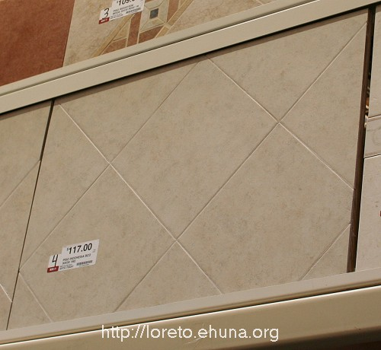
<center><a href="/pics/2007/03/homedepot/03-lowres/tiles/IMG_3168/IMG_3168_5.JPG" target="_blank"><img src="/pics/2007/03/homedepot/02-preview/tiles/IMG_3168/IMG_3168_5.JPG"></a></center>
Item No.: Tiles-02
Name: Piso Indonesia BCO (“Piso” means “Floor”)
Size: 30 x 30 1M2
Price: $117
Article No: 728207
Picture 1: <a href="/pics/2007/03/homedepot/03-lowres/tiles/IMG_3168/IMG_3168_5.JPG" target="_blank">Click Here</a> for low resolution
Picture 2: <a href="/pics/2007/03/homedepot/04-highres/tiles/IMG_3168/IMG_3168_5.JPG" target="_blank">Click Here</a> for high resolution
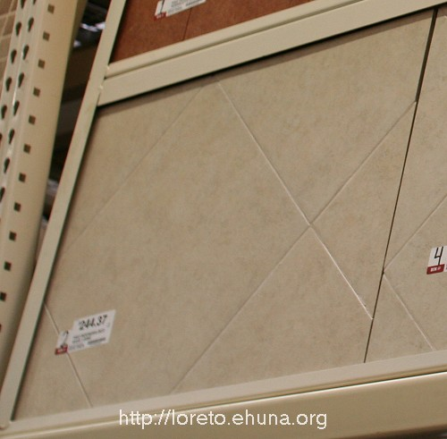
<center><a href="/pics/2007/03/homedepot/03-lowres/tiles/IMG_3168/IMG_3168_4.JPG" target="_blank"><img src="/pics/2007/03/homedepot/02-preview/tiles/IMG_3168/IMG_3168_4.JPG"></a></center>
Item No.: Tiles-03
Name: N/A
Size: N/A
Price: $244.37
Article No: N/A
Picture 1: <a href="/pics/2007/03/homedepot/03-lowres/tiles/IMG_3168/IMG_3168_4.JPG" target="_blank">Click Here</a> for low resolution
Picture 2: <a href="/pics/2007/03/homedepot/04-highres/tiles/IMG_3168/IMG_3168_4.JPG" target="_blank">Click Here</a> for high resolution
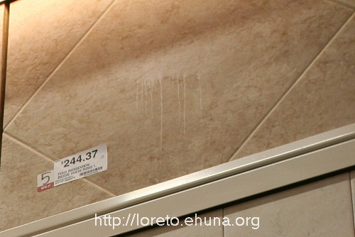
<center><a href="/pics/2007/03/homedepot/03-lowres/tiles/IMG_3168/IMG_3168_3.JPG" target="_blank"><img src="/pics/2007/03/homedepot/02-preview/tiles/IMG_3168/IMG_3168_3.JPG"></a></center>
Item No.: Tiles-04
Name: Piso Ridgeview Beige (“Piso” means “Floor”)
Size: 45 x 45 RD02
Price: $244.37
Article No: 533371
Picture 1: <a href="/pics/2007/03/homedepot/03-lowres/tiles/IMG_3168/IMG_3168_3.JPG" target="_blank">Click Here</a> for low resolution
Picture 2: <a href="/pics/2007/03/homedepot/04-highres/tiles/IMG_3168/IMG_3168_3.JPG" target="_blank">Click Here</a> for high resolution
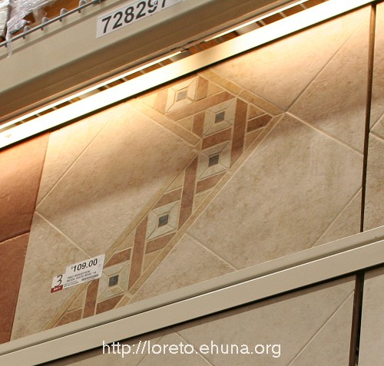
<center><a href="/pics/2007/03/homedepot/03-lowres/tiles/IMG_3168/IMG_3168_2.JPG" target="_blank"><img src="/pics/2007/03/homedepot/02-preview/tiles/IMG_3168/IMG_3168_2.JPG"></a></center>
Item No.: Tiles-05
Name: Piso Ridgeview Beige (“Piso” means “Floor”)
Size: 30 x 30 RD02
Price: $109.00
Article No: 533339
Picture 1: <a href="/pics/2007/03/homedepot/03-lowres/tiles/IMG_3168/IMG_3168_2.JPG" target="_blank">Click Here</a> for low resolution
Picture 2: <a href="/pics/2007/03/homedepot/04-highres/tiles/IMG_3168/IMG_3168_2.JPG" target="_blank">Click Here</a> for high resolution
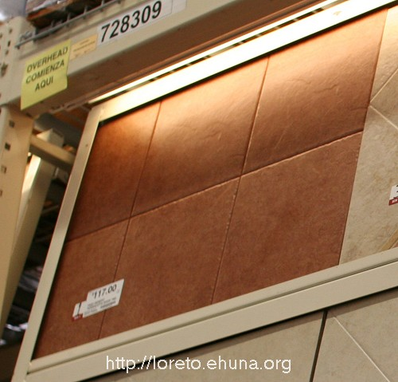
<center><a href="/pics/2007/03/homedepot/03-lowres/tiles/IMG_3168/IMG_3168_1.JPG" target="_blank"><img src="/pics/2007/03/homedepot/02-preview/tiles/IMG_3168/IMG_3168_1.JPG"></a></center>
Item No.: Tiles-06
Name: N/A
Size: N/A
Price: $117.00
Article No: N/A
Picture 1: <a href="/pics/2007/03/homedepot/03-lowres/tiles/IMG_3168/IMG_3168_1.JPG" target="_blank">Click Here</a> for low resolution
Picture 2: <a href="/pics/2007/03/homedepot/04-highres/tiles/IMG_3168/IMG_3168_1.JPG" target="_blank">Click Here</a> for high resolution
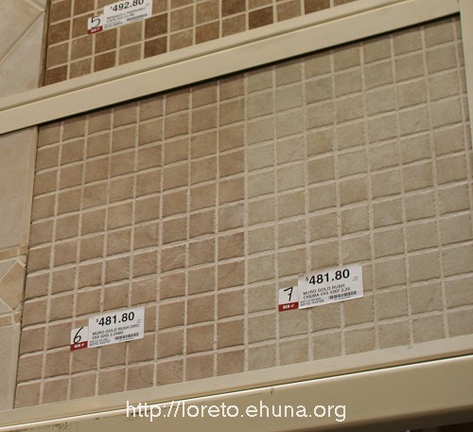
<center><a href="/pics/2007/03/homedepot/03-lowres/tiles/IMG_3169/IMG_3169_6.JPG" target="_blank"><img src="/pics/2007/03/homedepot/02-preview/tiles/IMG_3169/IMG_3169_6.JPG"></a></center>
Item No.: Tiles-07
Name: Muro Gold Rush Oro and Muro Gold Rush Crema (“Muro” means “Wall”)
Size: 5 x 5 5202 2.24M2
Price: $481.80
Article No: 533017 and 533765
Picture 1: <a href="/pics/2007/03/homedepot/03-lowres/tiles/IMG_3169/IMG_3169_6.JPG" target="_blank">Click Here</a> for low resolution
Picture 2: <a href="/pics/2007/03/homedepot/04-highres/tiles/IMG_3169/IMG_3169_6.JPG" target="_blank">Click Here</a> for high resolution
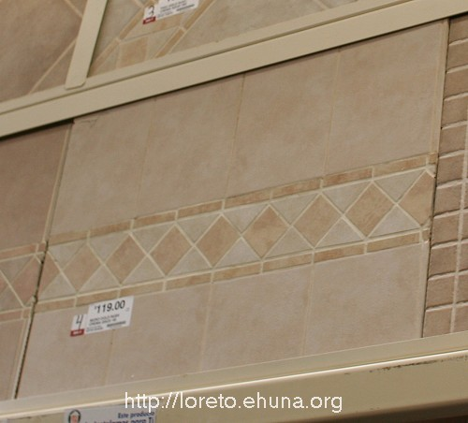
<center><a href="/pics/2007/03/homedepot/03-lowres/tiles/IMG_3169/IMG_3169_5.JPG" target="_blank"><img src="/pics/2007/03/homedepot/02-preview/tiles/IMG_3169/IMG_3169_5.JPG"></a></center>
Item No.: Tiles-08
Name: N/A
Size: N/A
Price: $119.00
Article No: N/A
Picture 1: <a href="/pics/2007/03/homedepot/03-lowres/tiles/IMG_3169/IMG_3169_5.JPG" target="_blank">Click Here</a> for low resolution
Picture 2: <a href="/pics/2007/03/homedepot/04-highres/tiles/IMG_3169/IMG_3169_5.JPG" target="_blank">Click Here</a> for high resolution
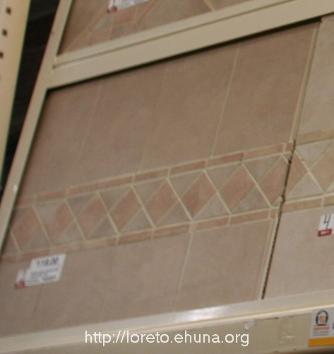
<center><a href="/pics/2007/03/homedepot/03-lowres/tiles/IMG_3169/IMG_3169_4.JPG" target="_blank"><img src="/pics/2007/03/homedepot/02-preview/tiles/IMG_3169/IMG_3169_4.JPG"></a></center>
Item No.: Tiles-09
Name: N/A
Size: N/A
Price: $119.00
Article No: N/A
Picture 1: <a href="/pics/2007/03/homedepot/03-lowres/tiles/IMG_3169/IMG_3169_4.JPG" target="_blank">Click Here</a> for low resolution
Picture 2: <a href="/pics/2007/03/homedepot/04-highres/tiles/IMG_3169/IMG_3169_4.JPG" target="_blank">Click Here</a> for high resolution
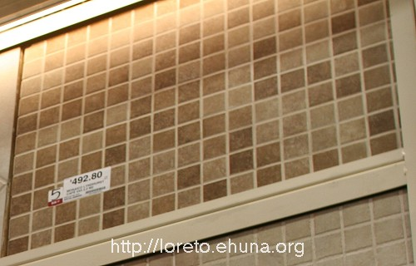
<center><a href="/pics/2007/03/homedepot/03-lowres/tiles/IMG_3169/IMG_3169_3.JPG" target="_blank"><img src="/pics/2007/03/homedepot/02-preview/tiles/IMG_3169/IMG_3169_3.JPG"></a></center>
Item No.: Tiles-10
Name: N/A
Size: N/A
Price: $492.80
Article No: N/A
Picture 1: <a href="/pics/2007/03/homedepot/03-lowres/tiles/IMG_3169/IMG_3169_3.JPG" target="_blank">Click Here</a> for low resolution
Picture 2: <a href="/pics/2007/03/homedepot/04-highres/tiles/IMG_3169/IMG_3169_3.JPG" target="_blank">Click Here</a> for high resolution
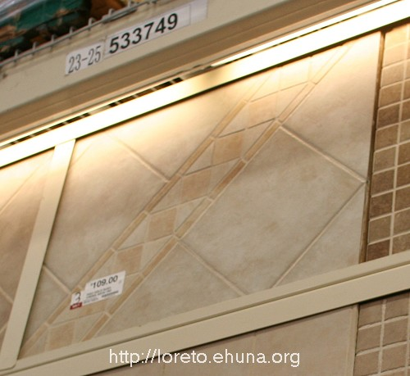
<center><a href="/pics/2007/03/homedepot/03-lowres/tiles/IMG_3169/IMG_3169_2.JPG" target="_blank"><img src="/pics/2007/03/homedepot/02-preview/tiles/IMG_3169/IMG_3169_2.JPG"></a></center>
Item No.: Tiles-11
Name: N/A
Size: N/A
Price: $109.00
Article No: N/A
Picture 1: <a href="/pics/2007/03/homedepot/03-lowres/tiles/IMG_3169/IMG_3169_2.JPG" target="_blank">Click Here</a> for low resolution
Picture 2: <a href="/pics/2007/03/homedepot/04-highres/tiles/IMG_3169/IMG_3169_2.JPG" target="_blank">Click Here</a> for high resolution
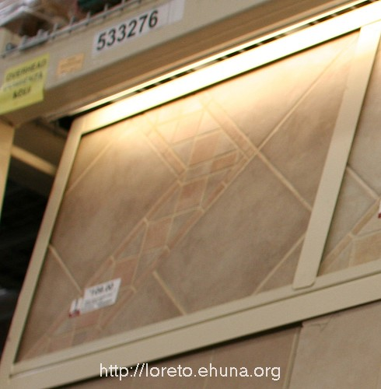
<center><a href="/pics/2007/03/homedepot/03-lowres/tiles/IMG_3169/IMG_3169_1.JPG" target="_blank"><img src="/pics/2007/03/homedepot/02-preview/tiles/IMG_3169/IMG_3169_1.JPG"></a></center>
Item No.: Tiles-12
Name: N/A
Size: N/A
Price: $109.00
Article No: N/A
Picture 1: <a href="/pics/2007/03/homedepot/03-lowres/tiles/IMG_3169/IMG_3169_1.JPG" target="_blank">Click Here</a> for low resolution
Picture 2: <a href="/pics/2007/03/homedepot/04-highres/tiles/IMG_3169/IMG_3169_1.JPG" target="_blank">Click Here</a> for high resolution
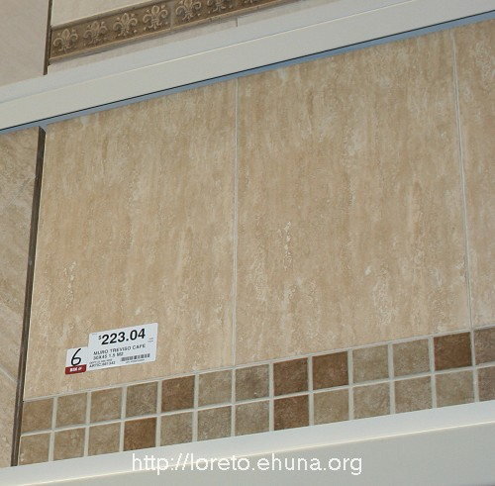
<center><a href="/pics/2007/03/homedepot/03-lowres/tiles/IMG_3167/IMG_3167_6.JPG" target="_blank"><img src="/pics/2007/03/homedepot/02-preview/tiles/IMG_3167/IMG_3167_6.JPG"></a></center>
Item No.: Tiles-13
Name: Muro Treviso Café (“Muro” means “Wall”)
Size: 30 x 45 1.5 M2
Price: $223.04
Article No: 581342
Picture 1: <a href="/pics/2007/03/homedepot/03-lowres/tiles/IMG_3167/IMG_3167_6.JPG" target="_blank">Click Here</a> for low resolution
Picture 2: <a href="/pics/2007/03/homedepot/04-highres/tiles/IMG_3167/IMG_3167_6.JPG" target="_blank">Click Here</a> for high resolution
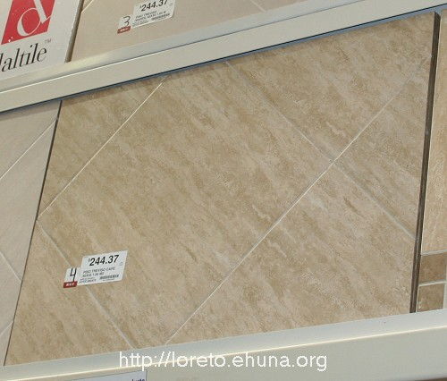
<center><a href="/pics/2007/03/homedepot/03-lowres/tiles/IMG_3167/IMG_3167_5.JPG" target="_blank"><img src="/pics/2007/03/homedepot/02-preview/tiles/IMG_3167/IMG_3167_5.JPG"></a></center>
Item No.: Tiles-14
Name: Piso Treviso Café (“Piso” means “Floor”)
Size: 45 x 45 1.64 M2
Price: $244.37
Article No: 580475
Picture 1: <a href="/pics/2007/03/homedepot/03-lowres/tiles/IMG_3167/IMG_3167_5.JPG" target="_blank">Click Here</a> for low resolution
Picture 2: <a href="/pics/2007/03/homedepot/04-highres/tiles/IMG_3167/IMG_3167_5.JPG" target="_blank">Click Here</a> for high resolution
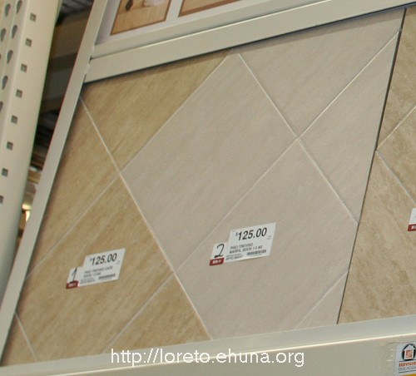
<center><a href="/pics/2007/03/homedepot/03-lowres/tiles/IMG_3167/IMG_3167_4.JPG" target="_blank"><img src="/pics/2007/03/homedepot/02-preview/tiles/IMG_3167/IMG_3167_4.JPG"></a></center>
Item No.: Tiles-15
Name: Piso Treviso Marfil (“Piso” means “Floor”)
Size: 30 x 30 1.0 M2
Price: $125.00
Article No: N/A
Picture 1: <a href="/pics/2007/03/homedepot/03-lowres/tiles/IMG_3167/IMG_3167_4.JPG" target="_blank">Click Here</a> for low resolution
Picture 2: <a href="/pics/2007/03/homedepot/04-highres/tiles/IMG_3167/IMG_3167_4.JPG" target="_blank">Click Here</a> for high resolution
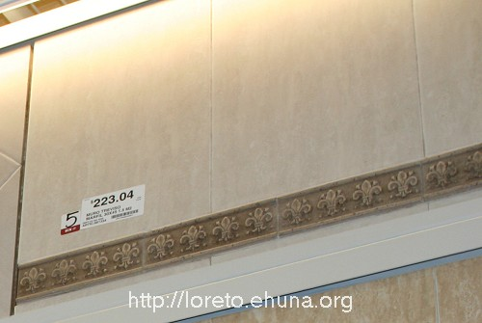
<center><a href="/pics/2007/03/homedepot/03-lowres/tiles/IMG_3167/IMG_3167_3.JPG" target="_blank"><img src="/pics/2007/03/homedepot/02-preview/tiles/IMG_3167/IMG_3167_3.JPG"></a></center>
Item No.: Tiles-16
Name: Muro Treviso Marfil (“Muro” means “Wall”)
Size: 30 x 45 1.5 M2
Price: $223.04
Article No: N/A
Picture 1: <a href="/pics/2007/03/homedepot/03-lowres/tiles/IMG_3167/IMG_3167_3.JPG" target="_blank">Click Here</a> for low resolution
Picture 2: <a href="/pics/2007/03/homedepot/04-highres/tiles/IMG_3167/IMG_3167_3.JPG" target="_blank">Click Here</a> for high resolution
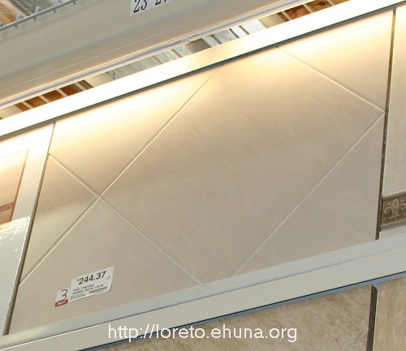
<center><a href="/pics/2007/03/homedepot/03-lowres/tiles/IMG_3167/IMG_3167_2.JPG" target="_blank"><img src="/pics/2007/03/homedepot/02-preview/tiles/IMG_3167/IMG_3167_2.JPG"></a></center>
Item No.: Tiles-17
Name: Piso Treviso Marfil (“Piso” means “Floor”)
Size: 45 x 45 1.64 M2
Price: $244.37
Article No: N/A
Picture 1: <a href="/pics/2007/03/homedepot/03-lowres/tiles/IMG_3167/IMG_3167_2.JPG" target="_blank">Click Here</a> for low resolution
Picture 2: <a href="/pics/2007/03/homedepot/04-highres/tiles/IMG_3167/IMG_3167_2.JPG" target="_blank">Click Here</a> for high resolution
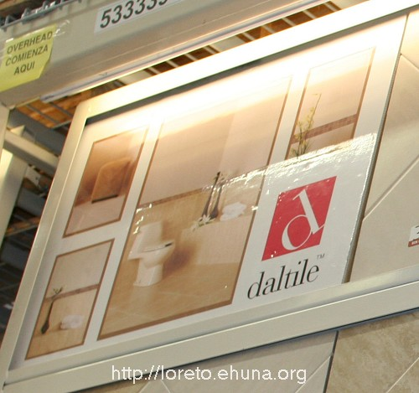
<center><a href="/pics/2007/03/homedepot/03-lowres/tiles/IMG_3167/IMG_3167_1.JPG" target="_blank"><img src="/pics/2007/03/homedepot/02-preview/tiles/IMG_3167/IMG_3167_1.JPG"></a></center>
Item No.: Tiles-18
Name: daltile, the brand for the previous tiles
Picture 1: <a href="/pics/2007/03/homedepot/03-lowres/tiles/IMG_3167/IMG_3167_1.JPG" target="_blank">Click Here</a> for low resolution
Picture 2: <a href="/pics/2007/03/homedepot/04-highres/tiles/IMG_3167/IMG_3167_1.JPG" target="_blank">Click Here</a> for high resolution

