Cabos Home Depot - Paint
This is the seventh in a series of articles with pictures of items we found available at the Paint Department at the Home Depot in Cabos San Lucas, BCS, Mexico.

Choose your Paint wisely – it can make a big difference
<center><img src=”/pics/2007/03/homedepot/02-preview/paintpreview.jpg”><br><i>Choose your Paint wisely – it can make a big difference </i></center>
See below for some of the Paint available or <a href=”/archives/cat_10_home_depot.html”>click here</a> for the index listing all items we found at the Home Depot in Cabos.
<b>Disclaimer</b>: please note that these items were available on 3/4/2007. Call Home Depot in Cabos before driving down to make sure the item you're interested in is still available. If you'd like to zoom in on a detail, download the "high-resolution" image (3456x2304). Unfortunately, I do not have prices for the items below.

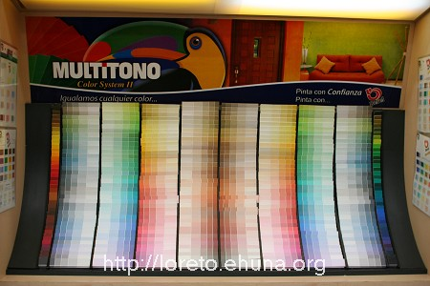
<center><a href="/pics/2007/03/homedepot/03-lowres/IMG_3171.JPG" target="_blank"><img src="/pics/2007/03/homedepot/02-preview/IMG_3171.JPG"></a></center>
Item No.: Paint-01
Name: Multitono
Picture 1: <a href="/pics/2007/03/homedepot/03-lowres /IMG_3171.JPG" target="_blank">Click Here</a> for low resolution
Picture 2: <a href="/pics/2007/03/homedepot/04-highres/IMG_3171.JPG" target="_blank">Click Here</a> for high resolution
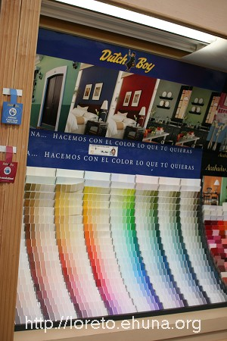
<center><a href="/pics/2007/03/homedepot/03-lowres/IMG_3170.JPG" target="_blank"><img src="/pics/2007/03/homedepot/02-preview/IMG_3170.JPG"></a></center>
Item No.: Paint-02
Name: Dutch Boy
Picture 1: <a href="/pics/2007/03/homedepot/03-lowres /IMG_3170.JPG" target="_blank">Click Here</a> for low resolution
Picture 2: <a href="/pics/2007/03/homedepot/04-highres/IMG_3170.JPG" target="_blank">Click Here</a> for high resolution
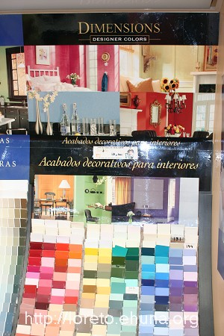
<center><a href="/pics/2007/03/homedepot/03-lowres/IMG_3172.JPG" target="_blank"><img src="/pics/2007/03/homedepot/02-preview/IMG_3172.JPG"></a></center>
Item No.: Paint-03
Name: Dimensions
Picture 1: <a href="/pics/2007/03/homedepot/03-lowres /IMG_3172.JPG" target="_blank">Click Here</a> for low resolution
Picture 2: <a href="/pics/2007/03/homedepot/04-highres/IMG_3172.JPG" target="_blank">Click Here</a> for high resolution
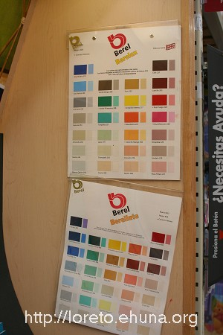
<center><a href="/pics/2007/03/homedepot/03-lowres/IMG_3173.JPG" target="_blank"><img src="/pics/2007/03/homedepot/02-preview/IMG_3173.JPG"></a></center>
Item No.: Paint-04
Name: Berel, Berelex and Berelinte
Picture 1: <a href="/pics/2007/03/homedepot/03-lowres /IMG_3173.JPG" target="_blank">Click Here</a> for low resolution
Picture 2: <a href="/pics/2007/03/homedepot/04-highres/IMG_3173.JPG" target="_blank">Click Here</a> for high resolution

